**Cloud Security Administration**

**Final Test**

**Name: Nirja Upendrabhai Patel**

**Student ID: 100965379**

**Created Resource Group :**

**VNet-1**

**Subnets**

**VNet2:**

**Subnet**

**Bastion**

**Firewall Disable :**

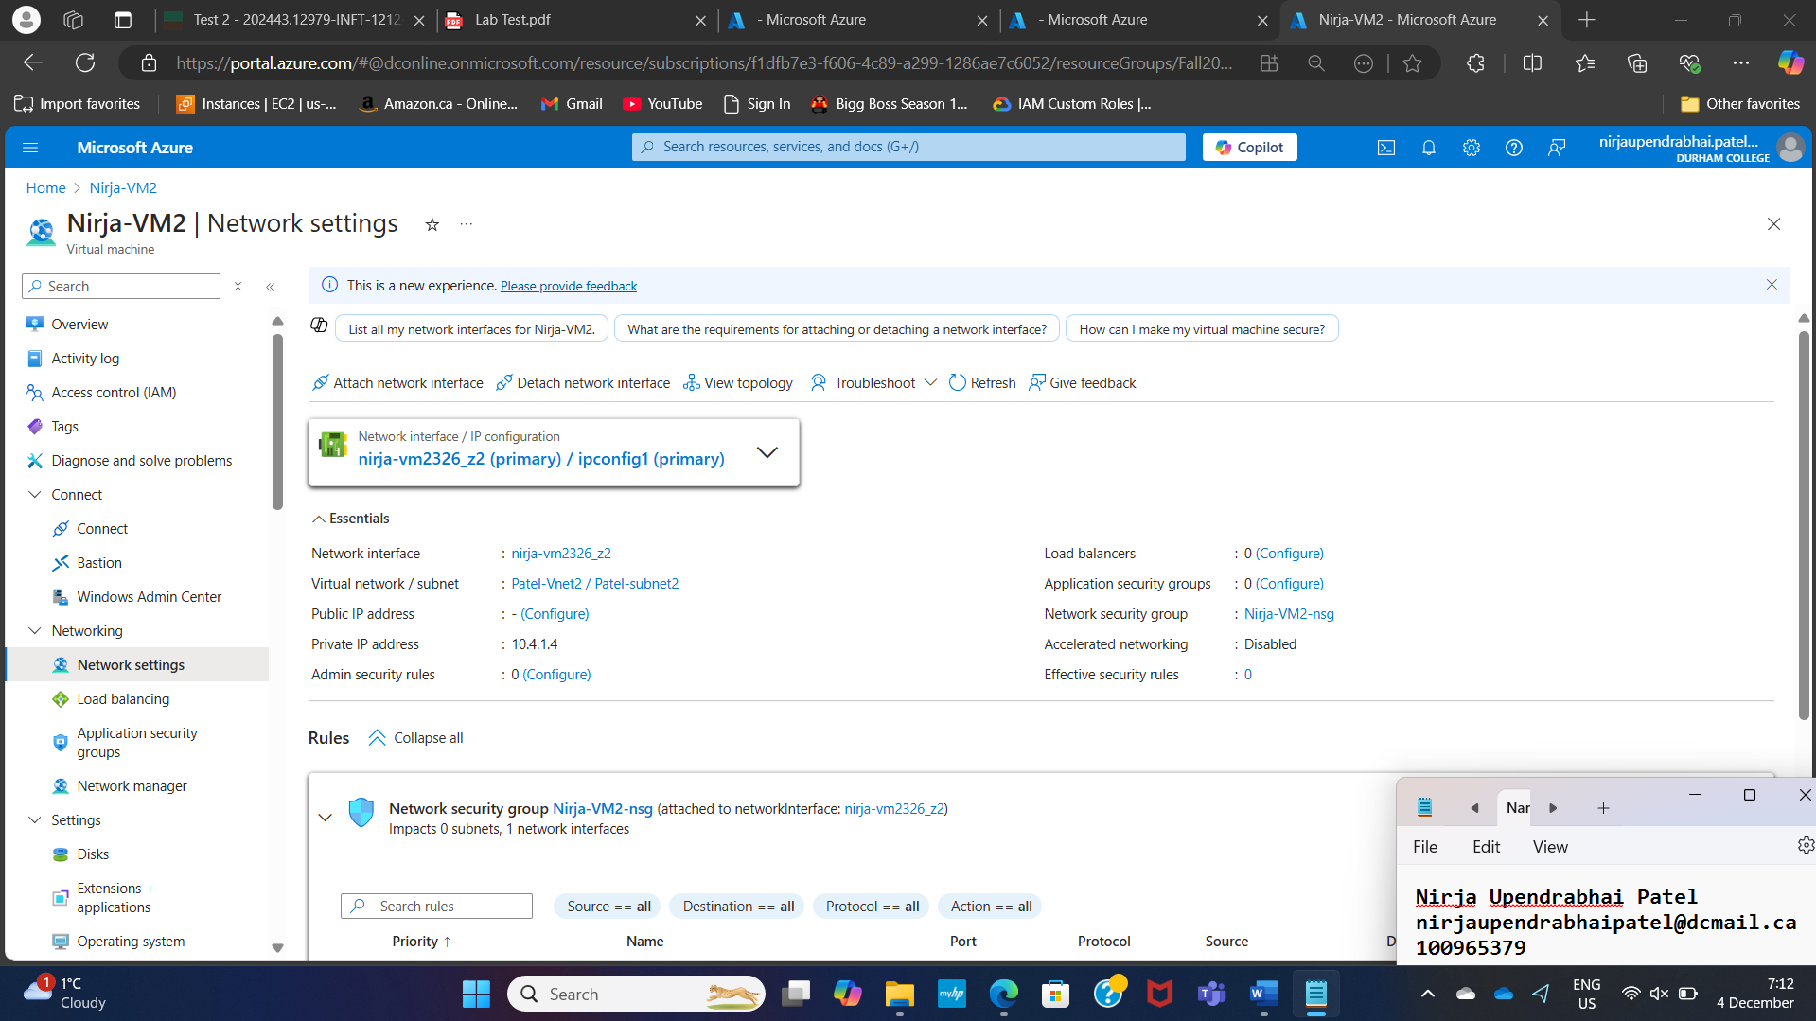

**VM1**

**VM2**

**Peering:**

**Ping vm1 to vm2**

**Ping vm2 to vm1**

